1. Write a program to set your name and age by a instance method and get them in an another instance method.

import java.util.Scanner;

public class NameAgeInstance

{

String get()

{

Scanner sc = new Scanner(System.in);

System.out.println("Enter age:");

String age = sc.nextLine();

System.out.println("Enter name:");

String name = sc.nextLine();

return display(age,name);

}

String display(String age, String name)

{

System.out.println("Age is: "+age);

System.out.println("Name is: "+name);

return age;

}

public static void main(String args[])

{

NameAgeInstance ob=new NameAgeInstance();

ob.get();

}}

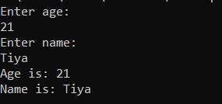

2 . Write a program to find the factorial of a number(**instance** **method**)

* Output – “Factorial of <given number> is <result>.

import java.util.Scanner;

public class FactorialInstance

{

int FactorialInstance(int a)

{

int fact=1;

for(int i=1;i<=a;i++)

{

fact=fact*i;

}

return fact;

}

public static void main (String args[])

{

Scanner sc = new Scanner(System.in);

System.out.println("Enter the number you want to find factorial");

int a = sc.nextInt();

FactorialInstance Ft=new FactorialInstance();

Ft.FactorialInstance(a);

int F;

F=Ft.FactorialInstance(a);

System.out.println("Factorial is: " +F);

}

}

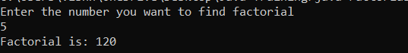

3. Write a program to check whether the given number is Palindrome/Not by using **instance** **method**.

* Method 1- to find the reverse(pass the number in argument)
* Method 2-to check palindrome/not

import java.util.Scanner;

public class PaliondromeInstance

{

int Find(int a)

{

int temp=a;

int r;

int rev=0;

while(temp!=0)

{

r=temp%10;

rev=rev*10+r;

temp=temp/10;

}

return Check(rev,a);

}

int Check(int rev, int a)

{

if(rev==a)

{

System.out.println("Given number is a paliondrome");

}

else

{

System.out.println("Given number is not a paliondrome");

}

return a;

}

public static void main (String args[])

{

Scanner sc = new Scanner(System.in);

System.out.println("Enter the number");

int a = sc.nextInt();

PaliondromeInstance P=new PaliondromeInstance();0

P.Find(a);

}

}

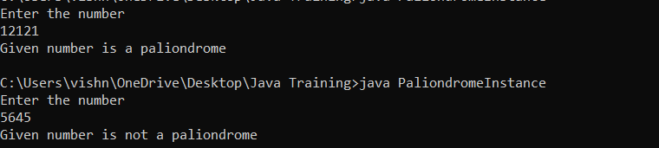

4.Write a program to check whether the candidate is eligible for Voting(Use **instance** **method** and boolean return type).

import java.util.Scanner;

public class VotingInstance

{

boolean ageCheck(int a)

{

if(a>18)

{

// System.out.println("Your are eligible to Vote");

return true;

}

else

{

//System.out.println("Your are not eligible to Vote");

return false;

}

}

public static void main (String args[])

{

System.out.println("Enter you Age:");

Scanner sc = new Scanner(System.in);

int a = sc.nextInt();

VotingInstance vo=new VotingInstance();

boolean i;

i=vo.ageCheck(a);

System.out.println("Is Voter: " +i);

}

}

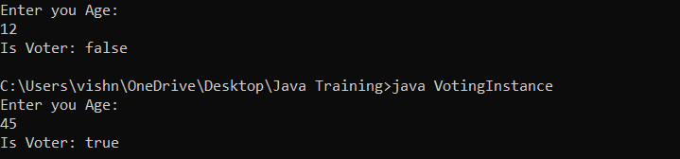

5. Write a program to deposit and withdraw amount from bank account(Withdrawal amount do not exceeds the current balance). Add an extra method to check the account balance. (**instance** **method**)

import java.util.Scanner;

public class BankInstance

{

Double a;

Double b;

Double c;

Double d;

Double Balancenew(Double b,Double c,Double d)

{

Double balance=b+c-d;

System.out.println("Deposited and the balance amount is: " +balance);

return balance;

}

Double BankDetails()

{

Scanner sc = new Scanner(System.in);

System.out.println("Enter the account number");

a = sc.nextDouble();

System.out.println("Enter the current balance");

b = sc.nextDouble();

System.out.println("Amount to be deposited");

c = sc.nextDouble();

System.out.println("Amount to be withdrawn");

d = sc.nextDouble();

if(d>b)

{

System.out.println("Balance not sufficient");

}

else if(b>d)

{

Balancenew(b,c,d);

}

return b;

}

public static void main (String args[])

{

BankInstance obj=new BankInstance();

obj.BankDetails();

}

}

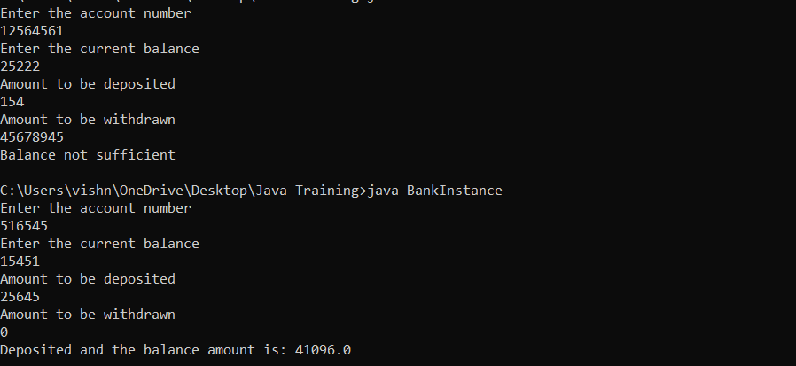

6. Write a program to check whether the customer have discount (get 20% discount if total amount is greater than 5000) or not and get the final amount in main method. (**instance** **method**)

* Get prices of items using parameterized method
* Method 1 - Calculate total amount
* Method 2 - Check discount

import java.util.Scanner;

public class ShoppingInstance

{

float total()

{

Scanner sc = new Scanner(System.in);

System.out.println("Enter the first product price");

float a = sc.nextFloat();

System.out.println("Enter the second product price");

float b = sc.nextFloat();

System.out.println("Enter the third product price");

float c = sc.nextFloat();

float sum=0;x

sum=a+b+c;

System.out.println("Total price is : "+sum);

return check(sum);

}

float check(float sum)

{

if (sum>5000)

{

float discount= (20*sum)/100;

float afterdiscount = sum - discount;

System.out.println("Total price after discount is : "+afterdiscount);

}

else

{

System.out.println("Have a nice day");

}

return sum;

}

public static void main (String args[])

{

ShoppingInstance St=new ShoppingInstance();

St.total();

}

}

